Supplementary Information-I

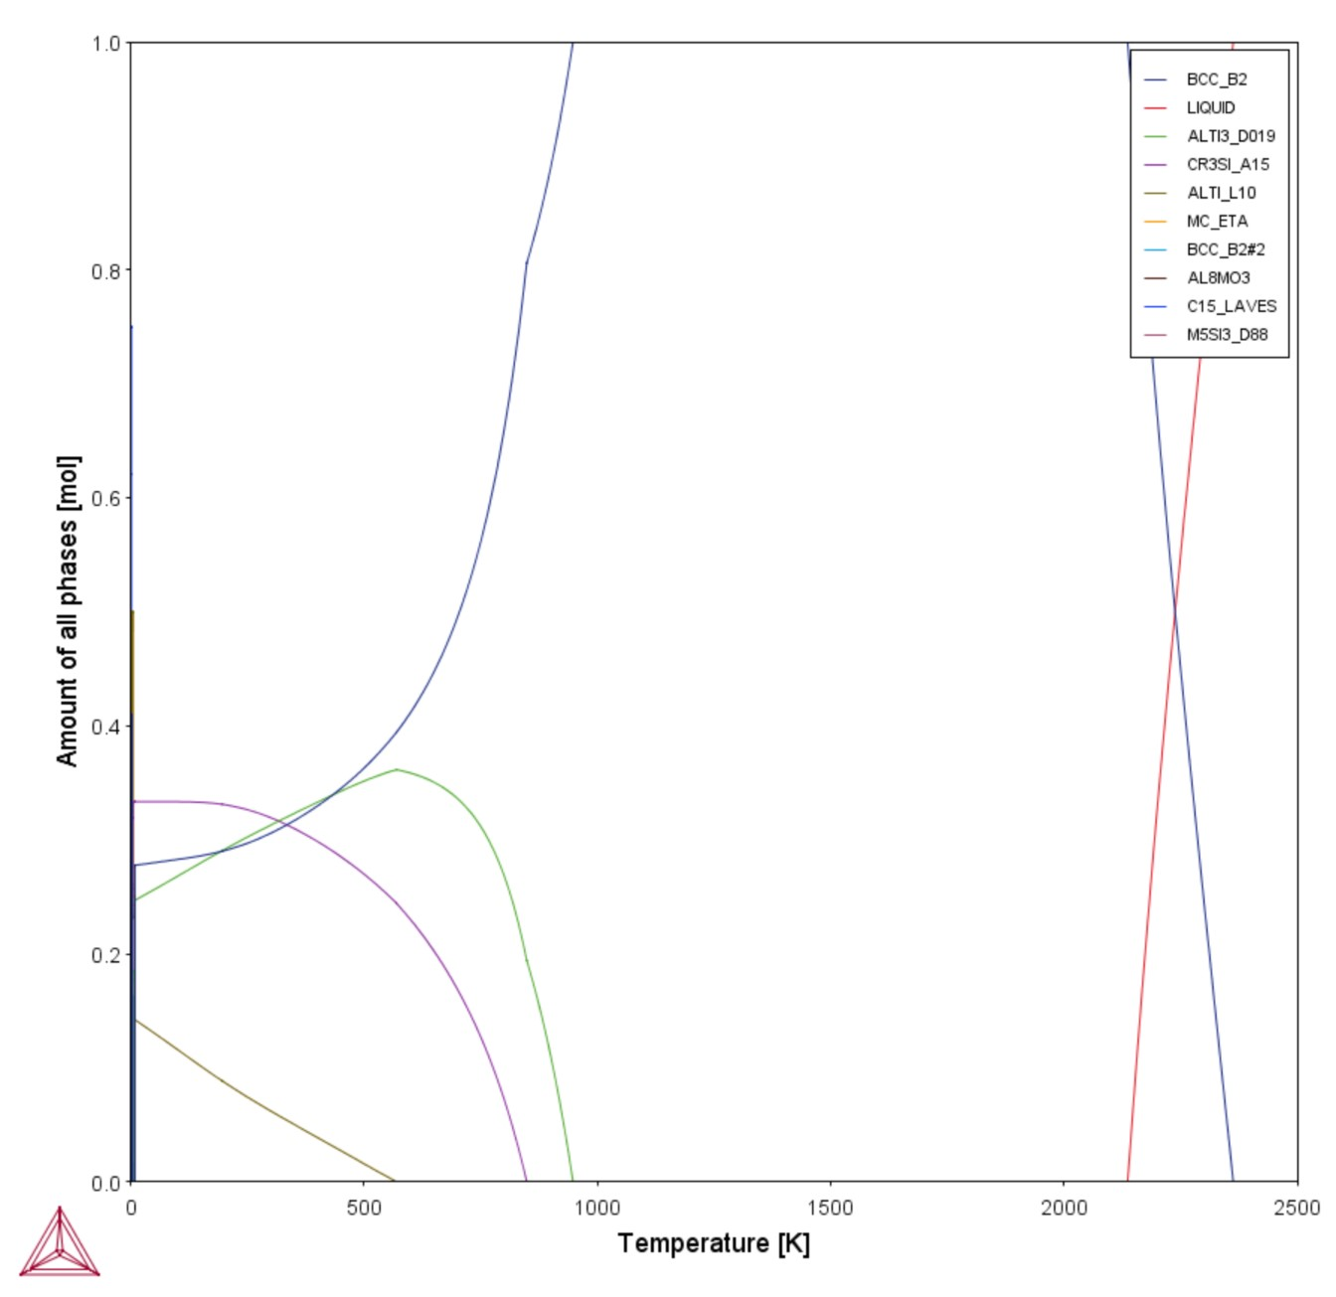

Figure S1. CALPHAD property diagram of AlTiVMo.

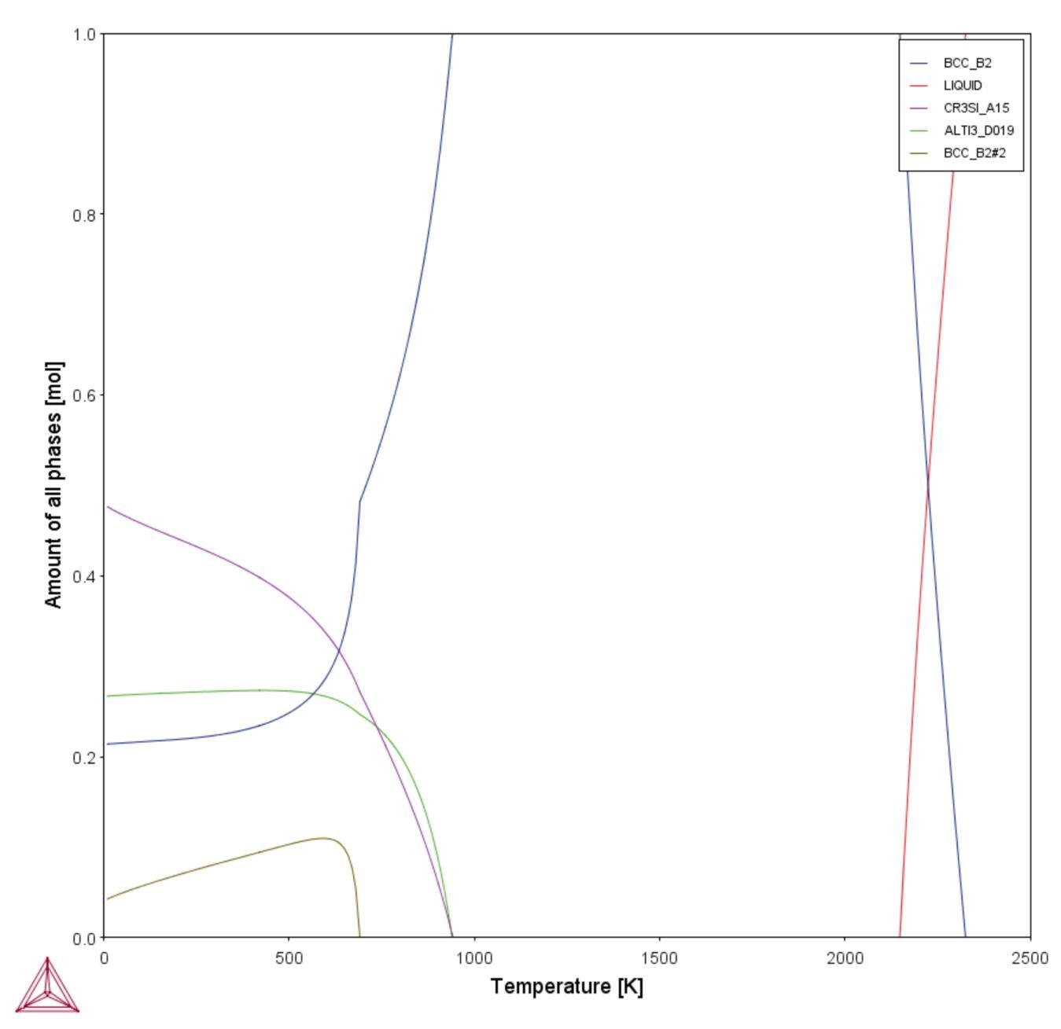

Figure S2. CALPHAD property diagram of AlTiVMoNb.

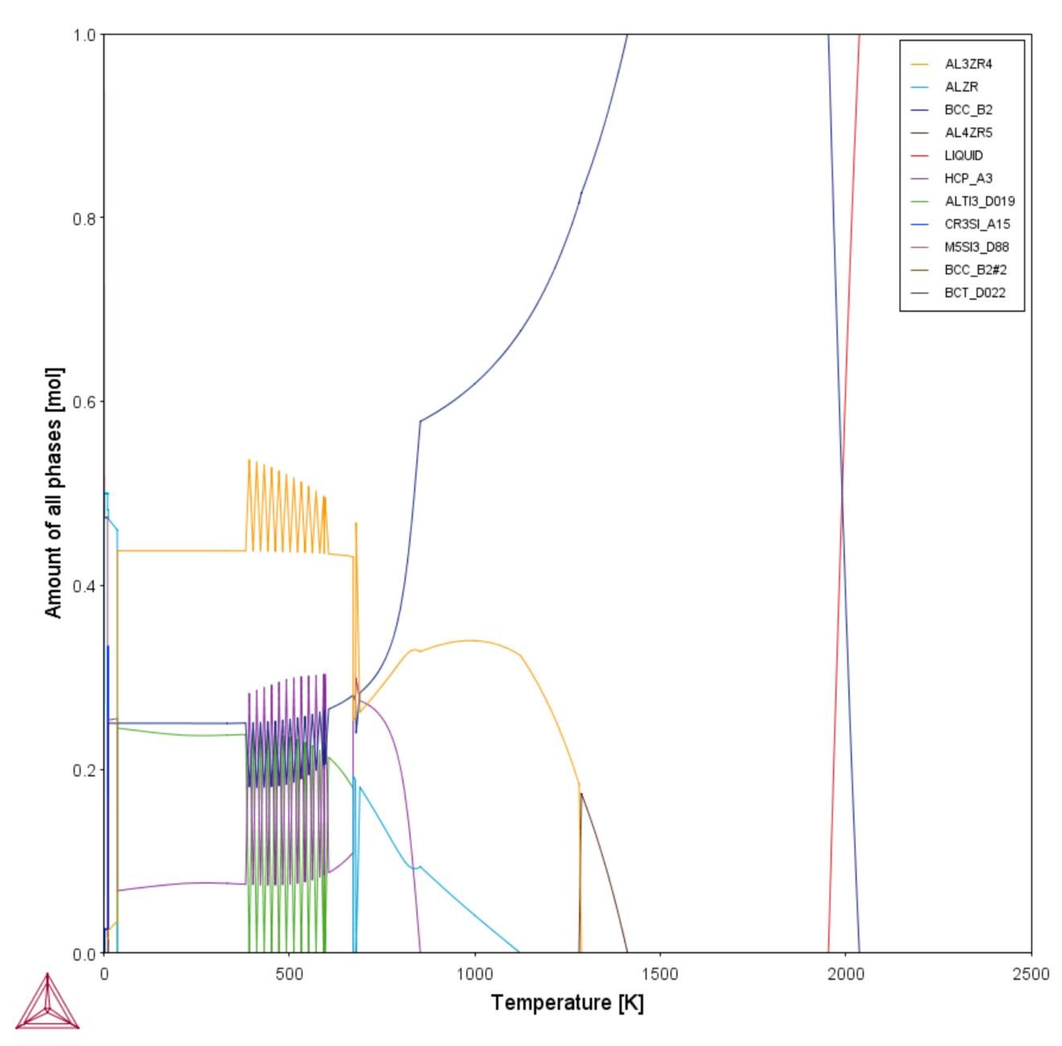

Figure S3. CALPHAD property diagram of AlTiZrNb.

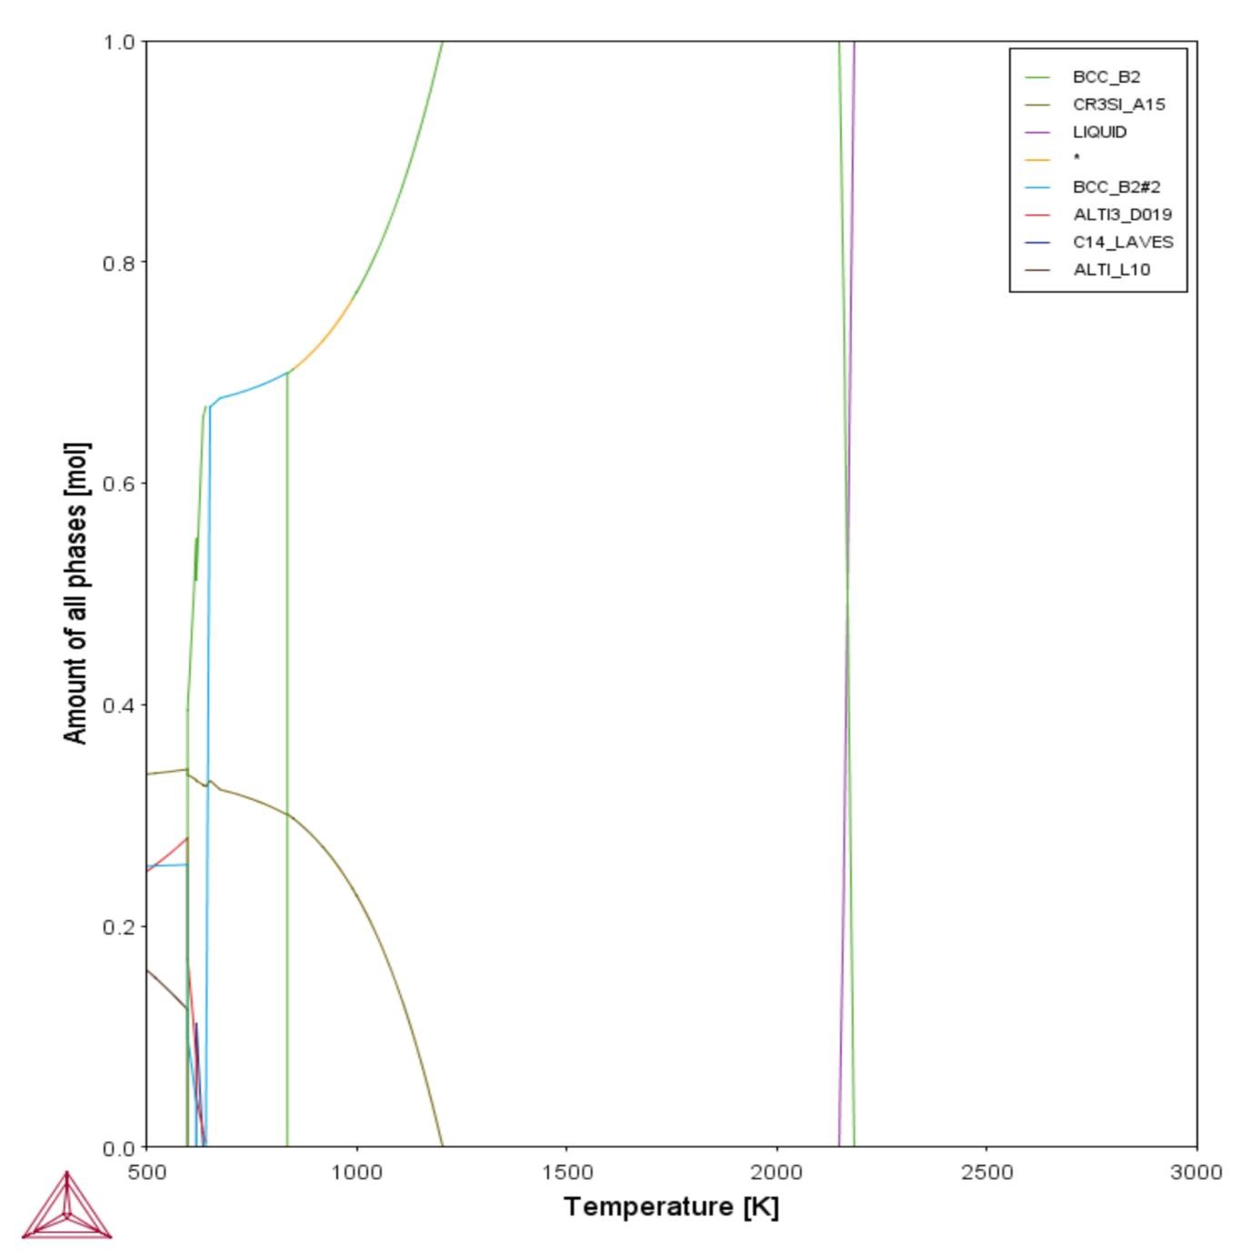

Figure S4. CALPHAD property diagram of AlTiCrMo.

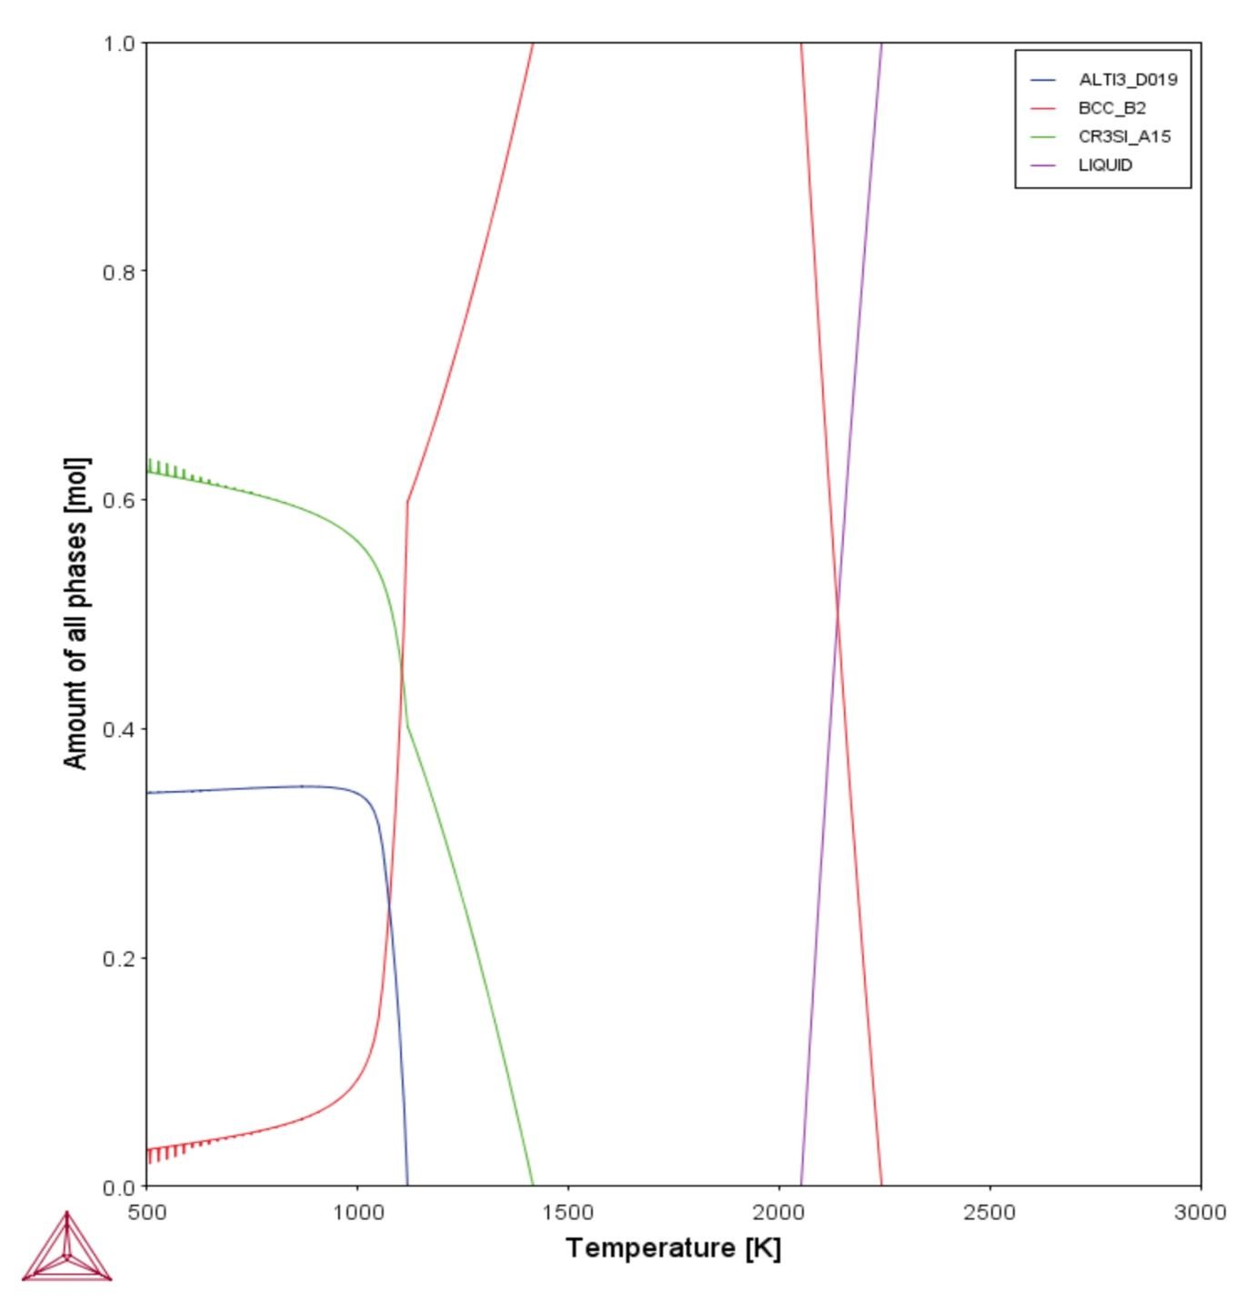

Figure S5. CALPHAD property diagram of AlTiNbMo.
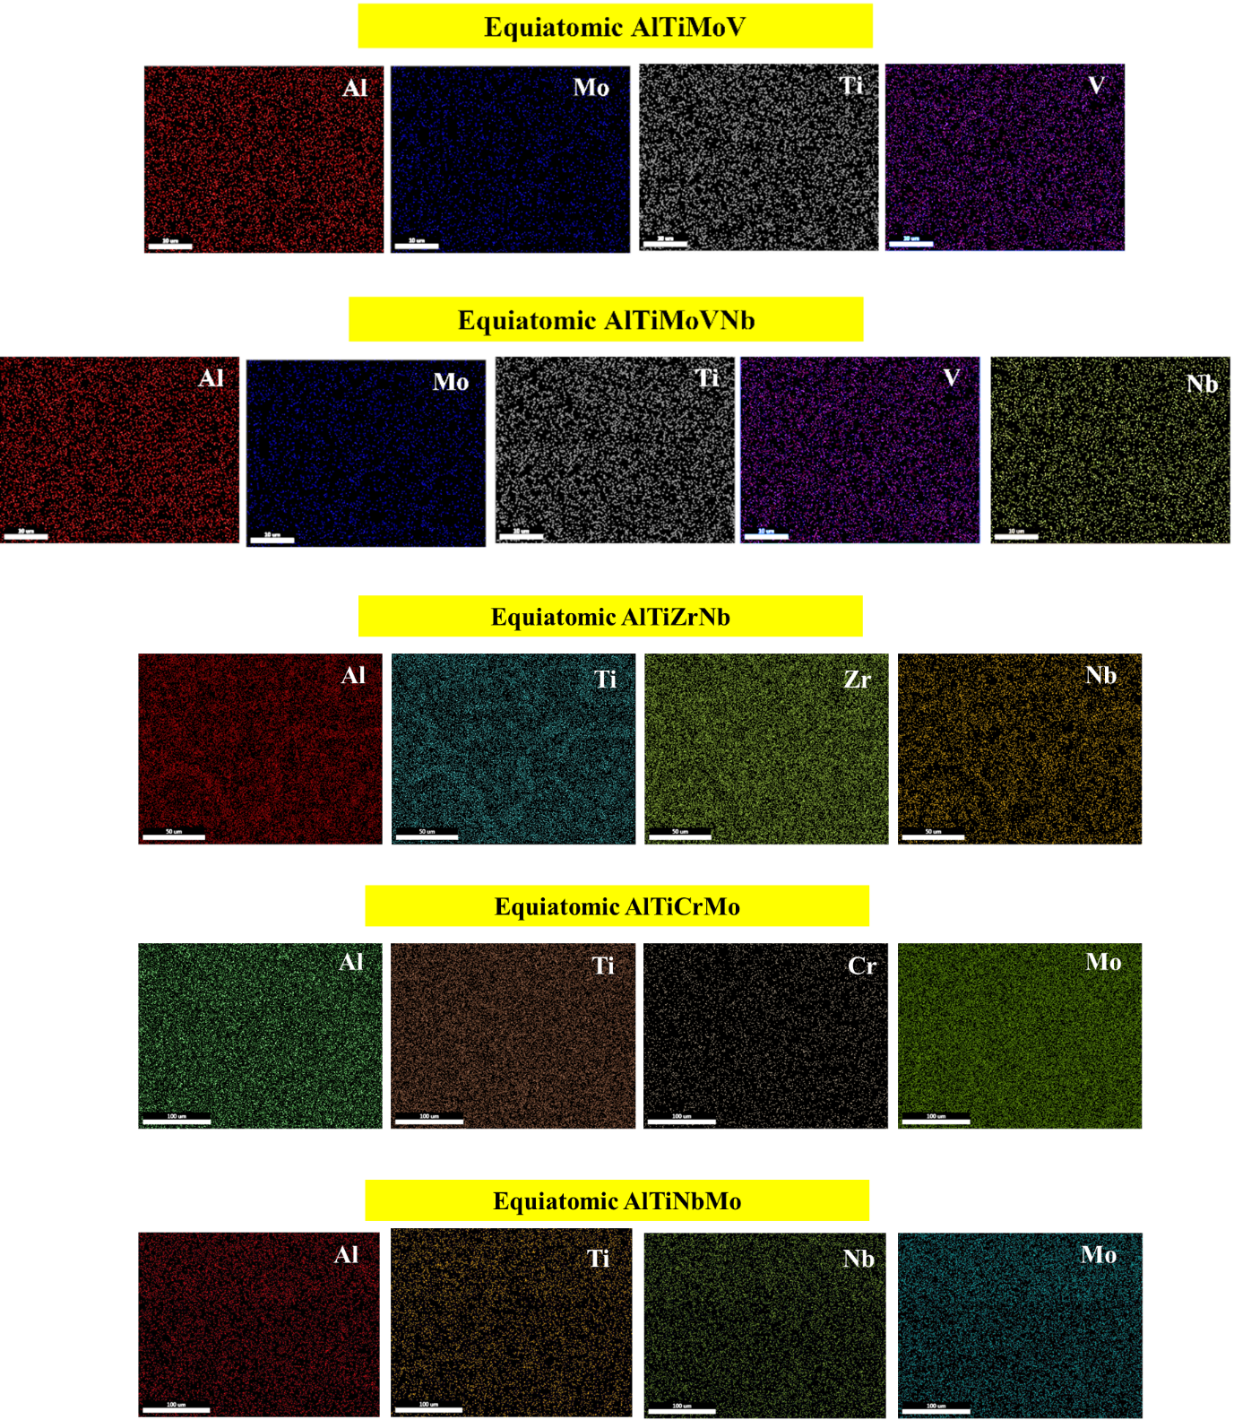

Figure S6. EDX-Elemental maps for the homogenized compositions.

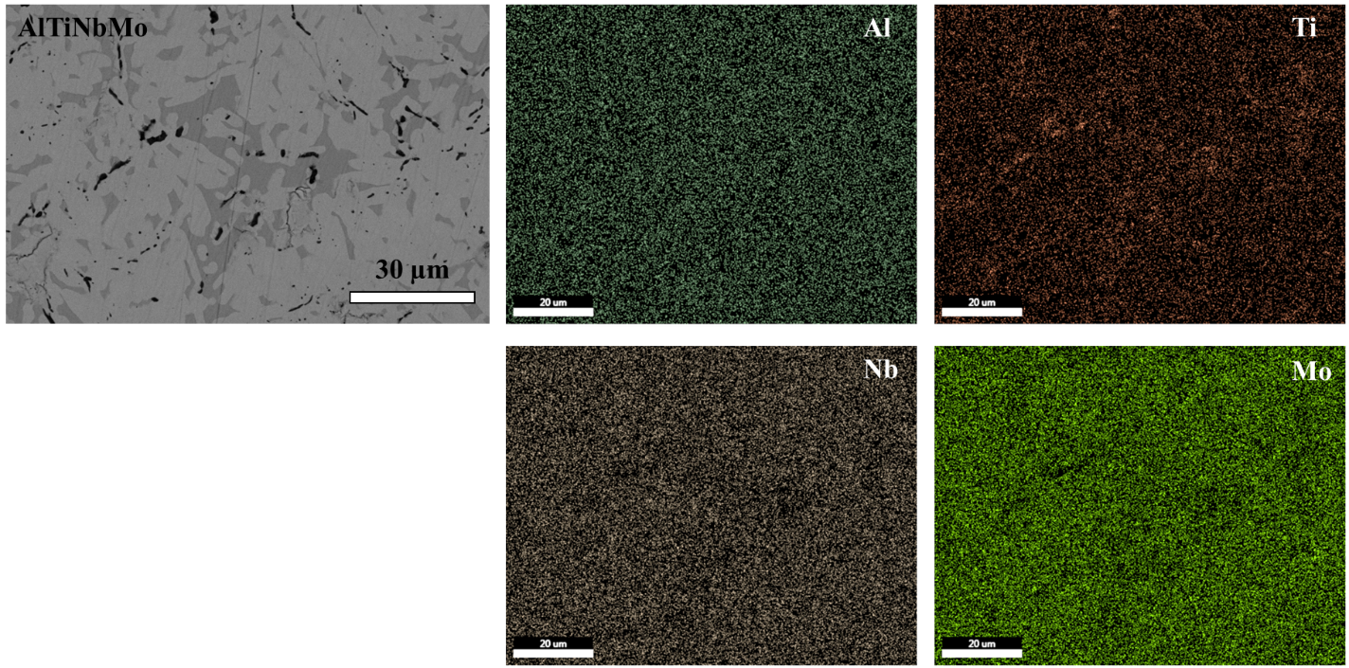

Figure 7. A magnified BSE-SEM image of AlTiNbMo showing different phase contrast and corresponding EDX-elemental maps for the homogenized compositions.

